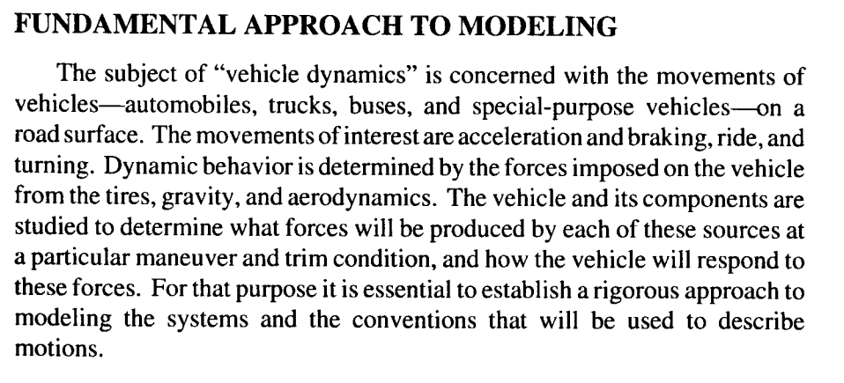 **Fundamental of vehicle dynamics**

A knowledge of the forces and moments generated by wheels is essential to understanding vehicle dynamics.

The subject of vehicle dynamics is concern with the movements of vehicles – automobiles, trucks, buses, and special-purpose vehicles – on a road surface. The movements of interest are acceleration, riding, braking and turning. Dynamic behavior is determined by the forces imposed on the vehicle from the wheels, gravity, and aerodynamics. The vehicles and ít components are studied to determine what force wll be produced by each of these source and how the vehicle will respond to these force. Since our car doesnot have a brake system, in this thesis we only investigate the vehicle dynamics in accerelation and turning.

**I. Tires Modeling**

**1. Slip**

In order to generate forces while rolling, the tire must *slip*. Slip occurs in different planes of the tire’s motion. Longitudinal slip will be considered first.

1. Để tạo lực khi quay, bánh xe phải trượt. Trước tiên ta xét đến sự trượt theo chiều dọc.

***Effective Rolling Radius*** When the tire is rolling freely (no driving or braking force applied), the *effective rolling radius Re* may be defined as follows:

$$R_{e}=\frac{v_{x}}{ω}$$

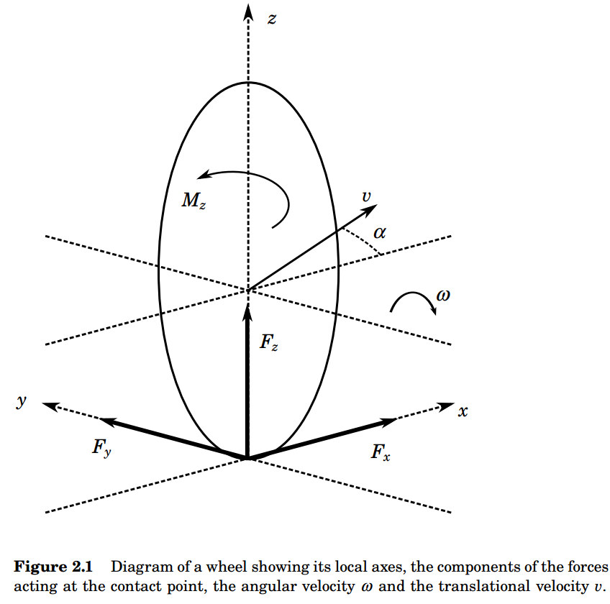

where *vx* is the longitudinal velocity of the wheel centre, and ω is the wheel’s angular velocity.

***Longitudinal Slip*** When a driving or braking torque is applied to the wheel, longitudinal slip develops. The *slip velocity* is the relative velocity of the tire contact patch with the ground, and is given by *vx* − *vc* where *vc* = *Re*ω is the circumferential velocity of the tire. The slip is obtained  
by normalizing the slip velocity. Two definitions of longitudinal slip are commonly used. The first, denoted λ, is normalized by the longitudinal velocity *vx*:

$$λ=-\frac{v_{x}-R_{e}ω}{v_{x}}$$

**Yaw stability control**

Prevent vehicles from spinning, drifting out and rolling over

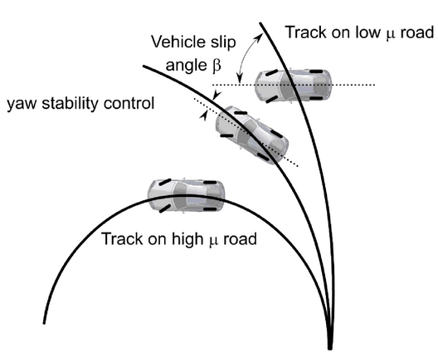

1. Để tạo lực khi quay, bánh xe phải trượt. Trước tiên ta xét đến sự trượt theo chiều dọc.

Bán kính lăn hiệu quả: Khi bánh xe lăn tự do (không bị ảnh hưởng bởi lực lái hay lực hãm phanh), bán kính lăn hiệu quả Re được xác định như sau:



$$R_{e}=\frac{v_{x}}{ω}$$

Trong đó vx là vận tốc theo chiều dọc của tâm bánh xe, và $ω$ là vận tốc góc của bánh xe

**Sự trượt theo chiều dọc:**

Khi một mô-men quay để lái hoặc hãm phanh tác động tới bánh xe, sự trượt theo chiều dọc xuất hiện. Vận tốc trượt là vận tốc tương đối của phần bánh xe tiếp xúc với mặt đất, và được tính bởi công thức $v_{x}=v_{c}$ trong đó ${v_{c}=R}_{e}ω$ là vận tốc đường tròn của bánh xe. Sự trượt được xác định bằng cách chuẩn hóa vận tốc trượt. Hai định nghĩa của sự trượt theo chiều dọc thường được sử dụng. Đầu tiên, ký hiệu λ được chuẩn hóa bởi vận tốc theo chiều dọc vx:

3.1 Coordinate Systems

Để thuận tiện cho việc xác định các công thức chuyển động, chúng tôi đặt ra một số hệ thống tọa độ.

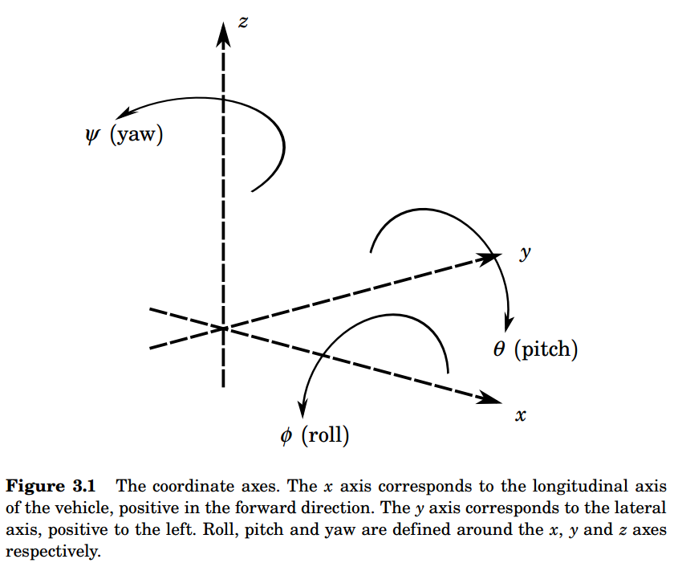

**Nguồn gốc của lực lốp xe**

**Lực tổng quát**

**Derivation of Tire Forces**  
In the derivation of the model it will be convenient to express the tireforces acting on the vehicle as resultant forces in the *x* and *y* directions of the *Sv* frame as well as a resultant moment about the *z* axis. These forces and moments will be referred to as *generalized forces*. By considering

the following expressions relating the individual tire forces to the generalized forces are obtained:

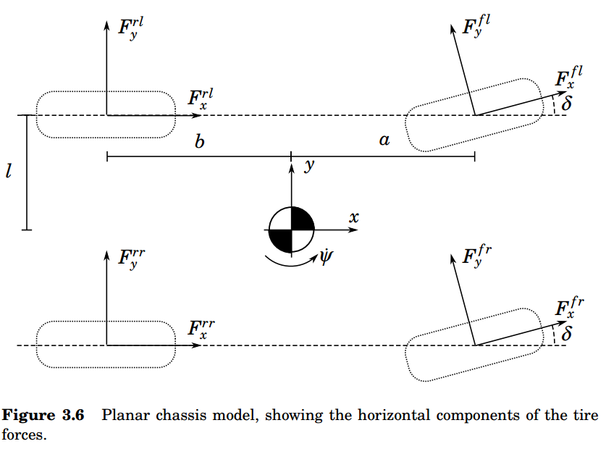

Xét hình bên trên, các công thức sau thể hiện mối quan hệ giữa lực của các bánh xe đơn và lực tổng quát.

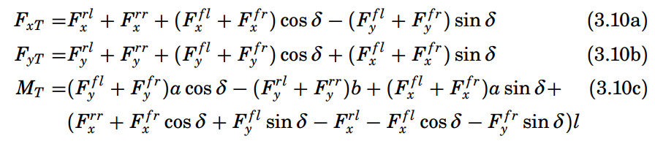

Với δ là góc lái (đo tại bánh xe)

**Chuyển động góc**

Công thức Euler chỉ ra tổng mô men xoắn trên một hệ thống bẳng tỉ lệ sự thay đổi mô-men góc.

***Angular Motion*** Euler’s equation states that the sum of the external torque acting on a system is given by the rate of change of angular momentum:

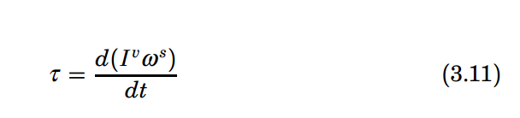

τ is the external torque or moment applied to the system, *Iv* is the  
inertia tensor relative to the coordinate frame in which the equations are  
to be derived, and ω*s* is the spacial angular velocity.

Với τ là moomen xoắn ngoài hoặc mô men đặt vào hệ thống, Iv là tensor quán tính liên quan với hệ trục tọa độ của phương trình và ωs là vận tốc góc trong không gian.

***Models for Control Design*** A linear model including roll dynamics could be used for roll control, and linear models are indeed extensively used in the literature. However, linear models use a number of assumptions and approximations which are unlikely to be valid during extreme maneuvering. These include:  
• Constant longitudinal velocity  
• Small steering angles  
• Linear tire forces  
• Simple approximations of tire slip values (α)  
These approximations imply that although linear models may be useful for designing control systems intended for use under ‘normal’ driving conditions, they may be of limited use for the case of extreme maneuvering, where nonlinearities in tire characteristics and vehicle dynamics must be taken into account. In addition, the load transfer which occurs during  
extreme maneuvering cannot be modeled with a single-track model.

**4.1 Static Rollover Analysis**  
The underlying cause of untripped vehicle rollover accidents is the rotational motion occurring when a vehicle makes a turn. Figure 4.1 illustrates a vehicle performing a turn with a radius of curvature ρ. In order to maintain the curved trajectory, a force directed towards the centre of rotation must act upon the centre of gravity (CG) of the vehicle. Another way of considering this is to use the method of D’Alembert [Spiegel, 1967], in which accelerations are represented by pseudo-forces. D’Alembert’s method allows dynamics problems to be viewed as statics problems. Figure 4.2 shows the pseudo-force *ma y* acting on the centre of gravity of a vehicle performing a turn. Note that the pseudo-force acts in the opposite direction to the acceleration that it replaces, that is, it is directed radially outwards from the centre of rotation. The external forces acting on the vehicle act at the road-tire contact point, not the centre of gravity, meaning that a resulting moment acts on the vehicle. The magnitude of the resulting moment depends on the height of the centre of gravity above the road. A higher centre of gravity gives a larger moment. This moment is counteracted by a moment due to the reaction (normal) forces acting on the tires on the outside of the turn. This moment depends on the track width of the vehicle (the distance between inner and outer wheels). Clearly, if the moment due to the rotational motion of the vehicle exceeds the moment due to the the normal forces on the tires, then the vehicle will begin to roll. A static condition for rollover can be derived from consideration of the resultant force vector acting on the center of gravity. If the line of action of the force lies outside the contact point of the outside wheels, then rollover will occur. Figure 4.3 illustrates the situation in the case of a vehicle without suspension. In this case, the condition for rollover to occur is:

